Exp: 5

AIM:

Step 1: Select the path

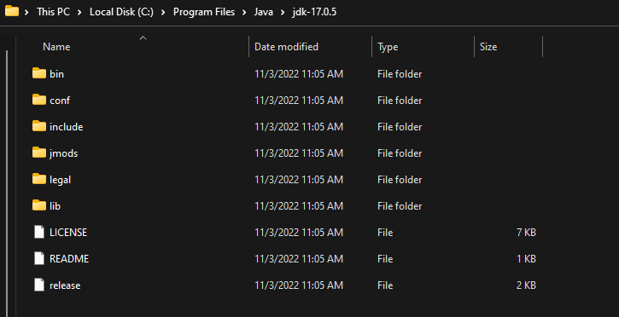

Step 2: Go to the environment variables , and then select "new" add variable name as well as paste the path in variable value

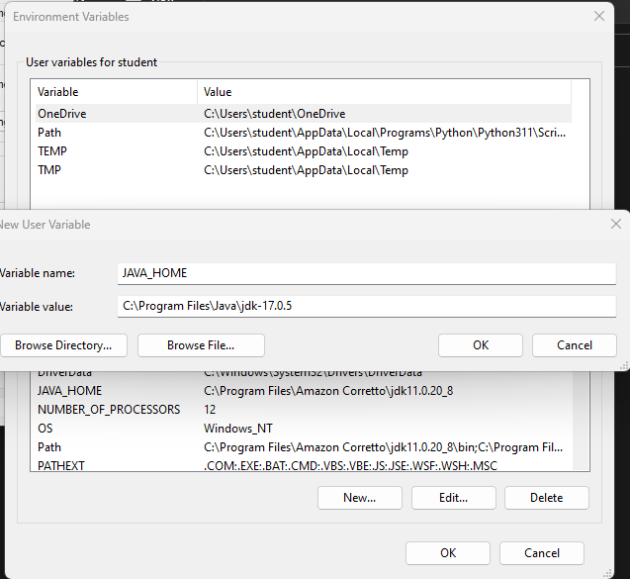

Step 3: Also do the same in new system variable

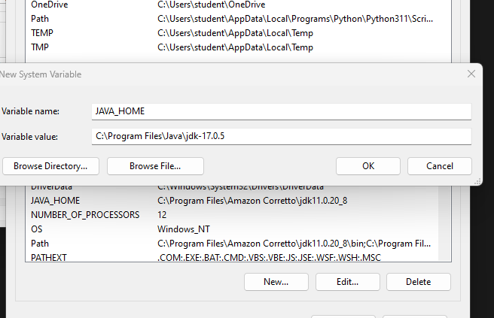

step 4 : <https://maven.apache.org/download.cgi> go to this link and install binary zip archive in link column.

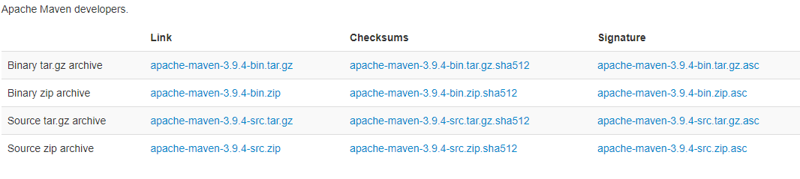

Step 5 : create a folder and name as "DevTools".

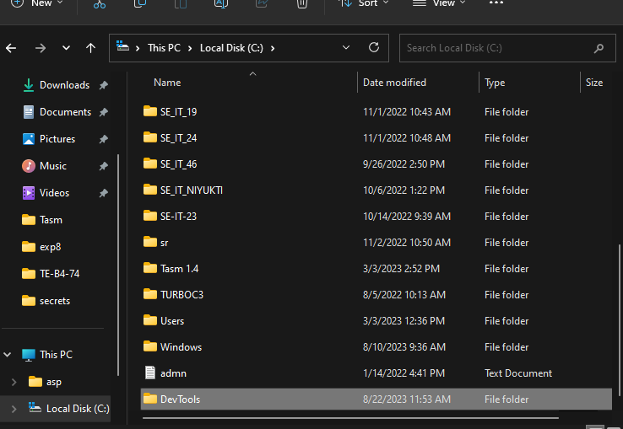

Step 6: select the path.

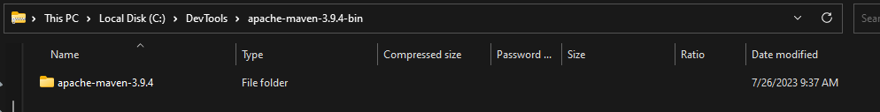

Step 7 : paste the path.

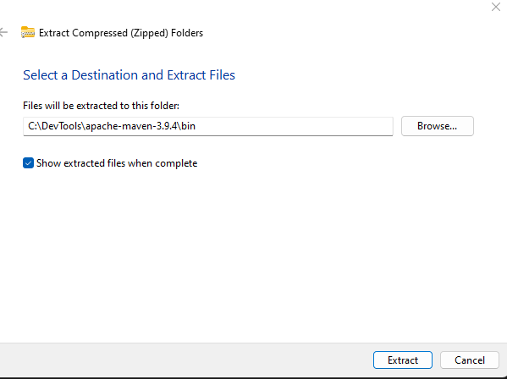

Step 8: set environment variables

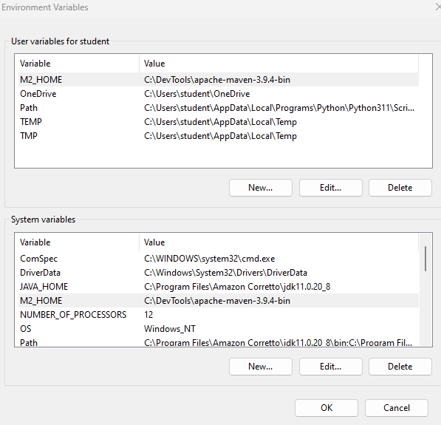

Step 9 : check the maven version and then open jenkins

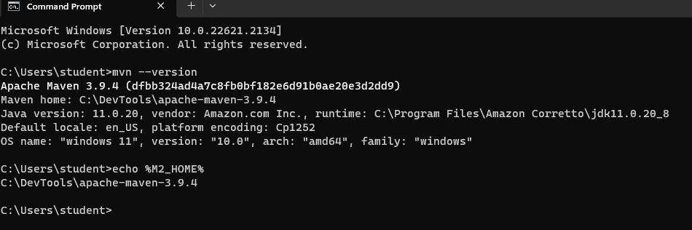

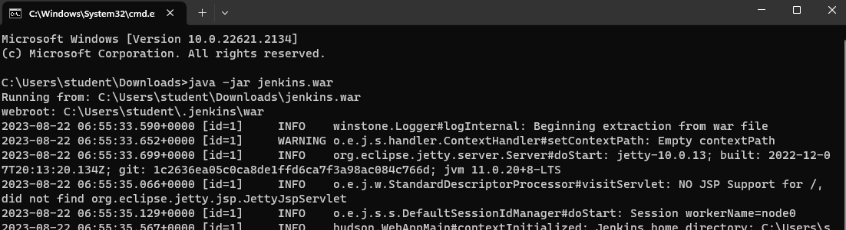

step 10 : go to jenkins.

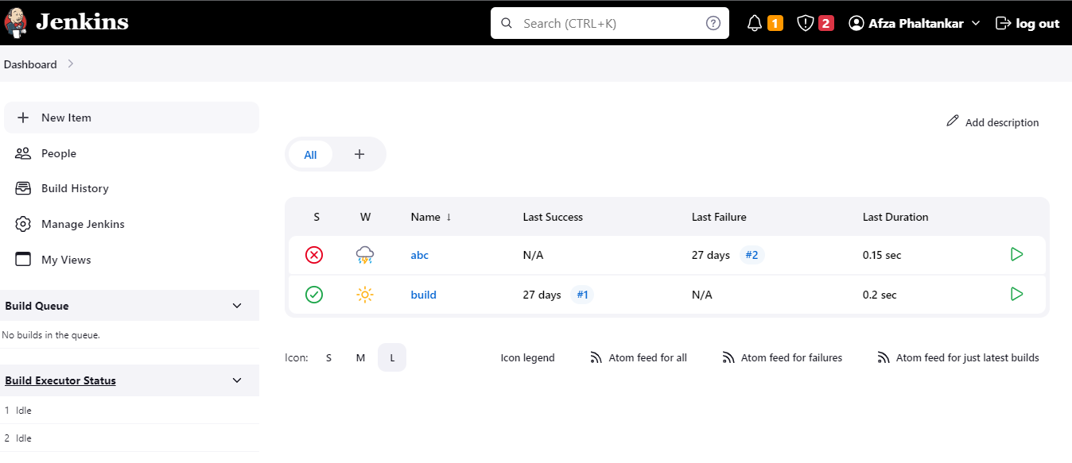

step 11: click on mange jenkins.

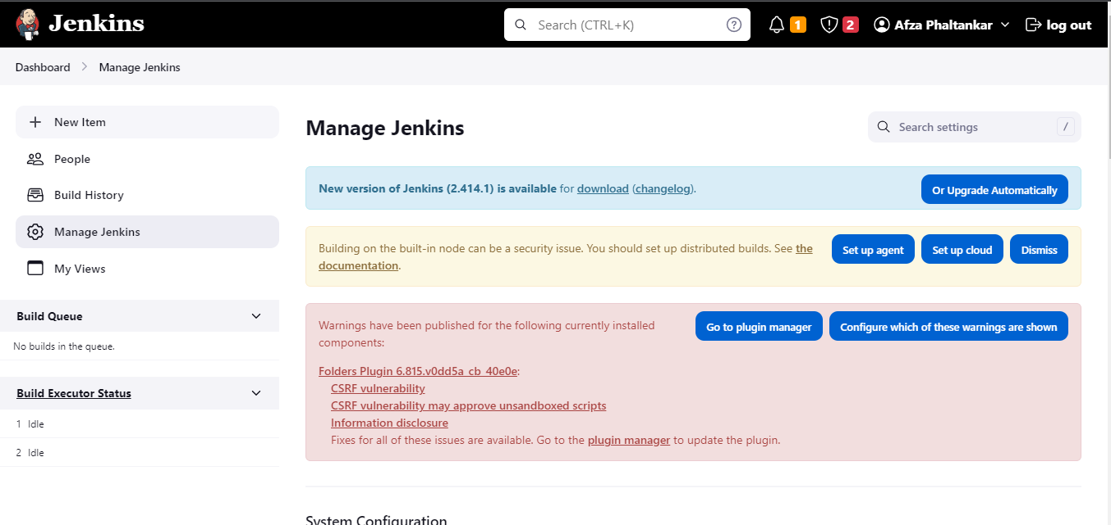

step 12 : click on plugins

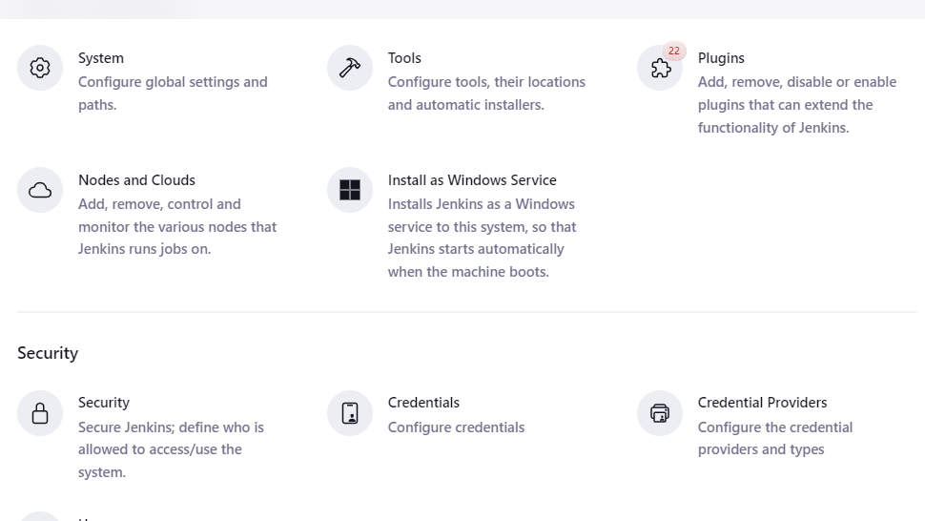

step 13 : type maven integration and select the checkbox and then click on download.

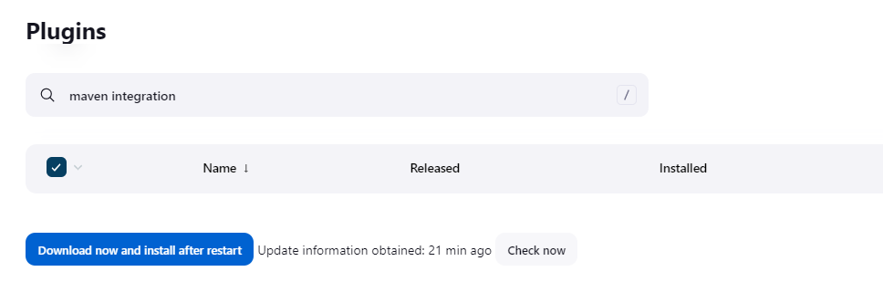

step 14 : it will start downloading

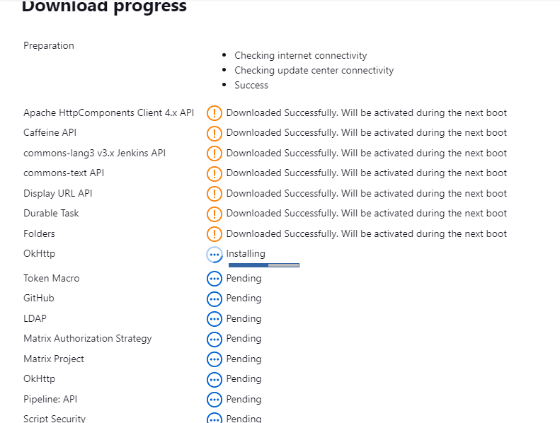

step 15 : go to new item and give name and then select maven project and click ok.

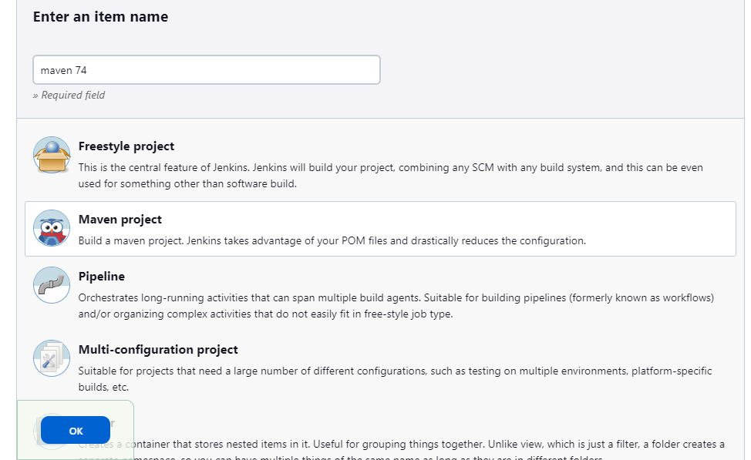

step 16 : select git radio button then type the url.

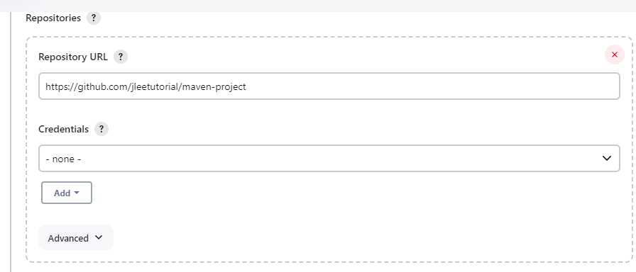

step 17: now apply and save

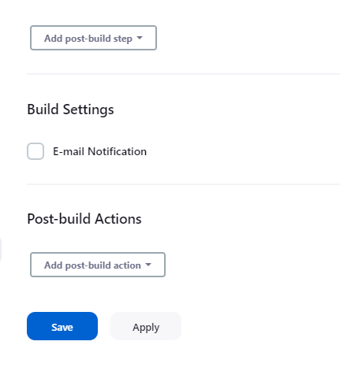

Step 18 : go to dashboard

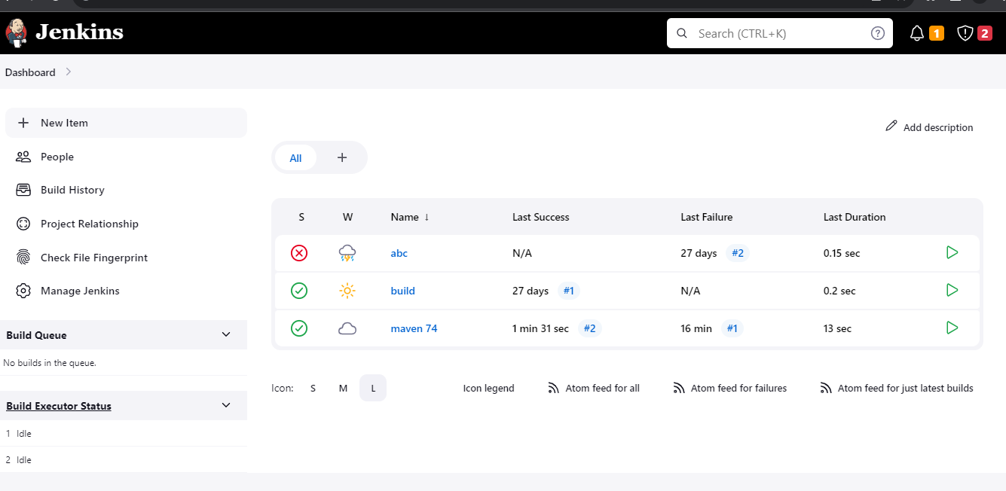

Step 19 : click on your status for eg : “maven 74” , to console output. Hence its successful

